STANDARD OPERATING PROCEDURE
3D Printer |  |  |  |  |  | SOP Number: |  | RA Number:
 |  |  |  |  |  | 020SOP |  | 021RA
DO NOT use / operate / this equipment or complete the task unless you have been trained.
POTENTIAL RISKS: Electricity, Extreme Temperatures, Mechanical, Fire, Hazardous Chemicals
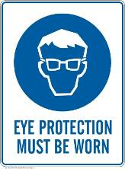 | 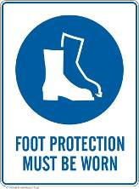 | 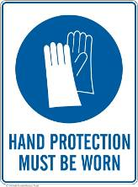 |  |  |  |  | 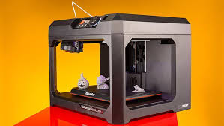

PRE-OPERATIONAL SAFETY
- Check for obvious faults and defects. Check the item has a current electrical test tag attached. Faulty equipment must not be used. Immediately report it.
- Ensure the risk assessment has been completed.
- Ensure no slip / trip hazards are present in the workspace and walkways.
- Locate and ensure you are familiar with the operation of the ON/OFF switch.
- Ensure print board is securely clipped onto the platform.
- Ensure the room is well ventilated with circulating air.
- Printer is located on a level, stable surface.

OPERATIONAL SAFETY PRECAUTIONS
- Switch on computer and login using the credentials located on the computer.
- Switch on the printer at the rear.
- Open UP! 3D printer software located on the desktop.
- Press the initialise button on the printers touch screen.
- Ensure the printer and filament spool is positioned correctly.
- Preheat the platform using the printer software.
- Ensure you have sufficient material on the spool and the allocated time available for the print job.
- Close doors and covers on the printer prior to starting print job.
- Keep fingers and foreign objects clear of the moving printer head.
- Before handling, allow sufficient time for the parts to cool once printing is complete.
- Do not touch the nozzle, print board or printed model by hand.
- Wear heat resistant gloves and safety glasses when handling the printer and model.
- Do not remove the model from the print board while the print board is still attached to the printer.
- Do not open printer doors whilst printing.
- When changing a filament spool, follow the manufacturer’s extraction and retraction guidelines.

HOUSEKEEPING
- Gently guide the printing platform out once printing has finished and printer is switched off.
- Save your work and shutdown the computer.
- Return all tooling and safety equipment to correct storage location.
- Leave the machine and work area in a safe, clean and tidy state.
- Dispose of waste material appropriately.
Date of last review: |  |  |  | Signature:

