STANDARD OPERATING PROCEDURE
Air Compressor |  |  |  |  |  | SOP Number: |  | RA Number:
 |  |  |  |  |  | 041SOP |  | 038RA
DO NOT use / operate / this equipment or complete the task unless you have been trained.
POTENTIAL RISKS: Unrestrained air hose whipping around; Material blown under pressure; Noise; slips, trips & falls; Hazardous Manual Tasks
 | 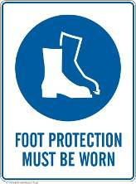 | 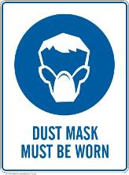 | Rings and Jewellry must not be worn. |  |  |  | 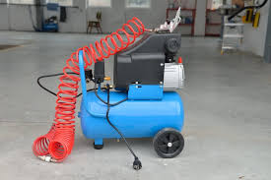

PRE-OPERATIONAL SAFETY
- Ensure the work area is well ventilated and not interfering with other students or activities.
- Visually check all air hoses and electrical leads used with the compressor for damage and slip/trip hazards.
- Ensure all guards for the compressor (e.g. belt and pulley cover) are in place and in good working order.
- Ensure you are familiar with the operation of the ON/OFF switch.
- Check that the regulator is set to the appropriate pressure for the activity.
- Check the oil level of the compressor in the oil sight glass

OPERATIONAL SAFETY PRECAUTIONS
- Ensure all attachments used with the air compressor are in good condition before using.
- Be careful when attaching and disconnecting tools to the air hose. Hold the air hose and tool firmly during this process.
- Check the compressor regularly, noting pressure increase and cut-out/cut-in pressure.
- Listen for any air leaks from any flexible airlines and immediately report any leaks.
- Adjust pressure regulator to suit work requirements
- Turn off and disconnect air hoses and electrical leads after use.
- Never leave air compressor and equipment unattended.

HOUSEKEEPING
- Leave the work area in a safe, clean and tidy state – remove any waste.
- Release condensation from the drain before storing away
- Air hoses and electrical leads should be coiled with large loops.
FORBIDDEN
- Never use compressed air to clean off clothes, workbenches or floor surfaces
- Never direct compressed air at your body or another person.

Date of last review: |  |  |  | Signature:

