STANDARD OPERATING PROCEDURE
Arc Welding |  |  |  |  |  | SOP Number: |  | RA Number:
 |  |  |  |  |  | 046SOP |  | 042RA
DO NOT use / operate / this equipment or complete the task unless you have been trained.
POTENTIAL RISKS: Welding flash - eye injury; Burns; Electric Shock.
 | 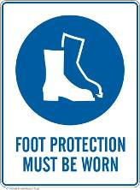 | 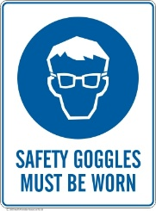 |  |  |  |  | 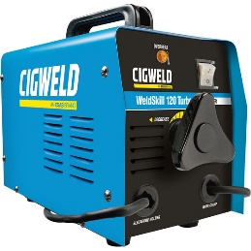

PRE-OPERATIONAL SAFETY
- Ensure the welder is used in a suitable safe work area.
- Ensure all cables are correctly fastened, free of cracks and splits and unwound before work.
- Keep the area clean & free of grease, oils & flammables.
- Ensure other workers are protected from any UV flash.
- Ensure the area is well ventilated (with fume extraction as required).

OPERATIONAL SAFETY PRECAUTIONS
- Ensure the welder is correctly set up for current, voltage and good earth.
- Ensure that other workers in this locality are protected from any UV & IR radiation flash. Always close the UV curtain to the welding bay or erect a UV screen.
- Ensure the welding return cable (earth) makes firm contact to provide a good electrical contact.
- Ensure your work-piece has been prepared to be free of any paint, oxides or other surface finishes ensuring a good electrical contact.
- Take particular care to avoid accidental UV welding flash to the skin or eyes.
- Never leave the welder running unattended.
- Regularly inspect the welding tip and shield for damage.
- When welding is finished or interrupted, turn off the welder and secure the handpiece safely.
- Ensure the work area can isolate hot areas from workers to avoid hot surfaces until job is cool.

HOUSEKEEPING
- Ensure the welder is switched off (and fume extraction if used).
- Check for any damage to welder and cables at the end of job. Wind up cables.
- Hang up the welding handpiece and cables securely.
- Check contact points for damage or corrosion.
- Leave the work area and welding bench in a safe, clean, and tidy condition.
Date of last review: |  |  |  | Signature:

