STANDARD OPERATING PROCEDURE
Belt Sander - Fixed |  |  |  |  |  | SOP Number: |  | RA Number:
 |  |  |  |  |  | 045SOP |  | 041RA
DO NOT use / operate / this equipment or complete the task unless you have been trained.
POTENTIAL RISKS: Abrasions; Foreign body in eyes; Electric shock; excessive dust.
 | 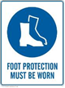 |  |  |  | Gloves, rings and jewellry must not be worn   |  | 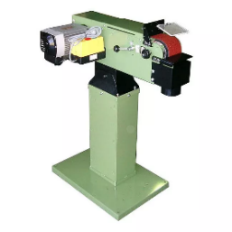

PRE-OPERATIONAL SAFETY
- Check workspaces and walkways to ensure no slip/trip-hazards are present.
- Locate and ensure you are familiar with the operation of the ON/OFF starter and E-Stop (if fitted).
- Check the table is set not more than 2mm from disc.
- Check abrasive disc is in a serviceable condition.
- Start the dust extraction unit before using the machine.
- Faulty equipment must not be used. Immediately report suspect equipment.

OPERATIONAL SAFETY CHECKS
- Allow machine to reach maximum revolutions before operating to avoid overloading.
- NEVER attempt to sand very small items, lift or tilt the material while sanding.
- Always place material on the table on the downward side of the disc travel and hold it securely on the table surface.
- Hold material firmly against the table before applying pressure on abrasive disc.
- Keep hands/fingers clear of abrasive disc while sanding.
- NEVER attempt to or try to sharpen metal items.
- NEVER leave the machine running unattended.
- Before making adjustments switch off and bring the machine to a complete standstill.

FORBIDDEN
- Attempting to sand very small items
- Attempting to sharpen tools
- Attempting to sand metal

HOUSEKEEPING
- Switch off the machine.
- Leave the machine in a safe, clean and tidy state.
Date of last review: |  |  |  | Signature:

