STANDARD OPERATING PROCEDURE
Belt and Disc Sander |  |  |  |  |  | SOP Number: |  | RA Number:
 |  |  |  |  |  | 052SOP |  | 048RA
DO NOT use / operate / this equipment or complete the task unless you have been trained.
POTENTIAL RISKS:
 |  |  | Rings and jewellry must not be worn. |  | Glove must not be worn when using this machine. |  | 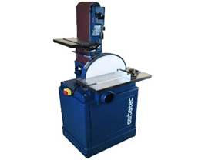

PRE-OPERATIONAL SAFETY
- Check workspaces and walkways to ensure no slip/trip hazards are present.
- Ensure you are familiar with the operation of the ON/OFF starter and E-Stop (if fitted).
- Check the table is set not more than 2mm from disc.
- Check belts and discs are in a serviceable condition.
- Operator must be positioned out of direct line of abrasive belt at all times.
- Ensure dust extraction is on before operating machine.
- Faulty equipment must not be used. Immediately report suspect machinery.

OPERATIONAL SAFETY PRECAUTIONS
- Allow machine to reach maximum revolutions before operating to avoid overloading.
- Always place material on the table on the downward side of the disc travel to hold it down on the table surface.
- Hold material firmly against stops or table before applying pressure on abrasive.
- Keep fingers clear of disc or belt while sanding.
- Never leave the machine while it is running.
- Before making adjustments switch off and bring the machine to a complete standstill.

HOUSEKEEPING
- Switch off the machine.
- Leave the machine in a safe, clean and tidy state.
Date of last review: |  |  |  | Signature:

