STANDARD OPERATING PROCEDURE
Cold Cut Saw |  |  |  |  |  | SOP Number: |  | RA Number:
 |  |  |  |  |  | 048SOP |  | 044RA
DO NOT use / operate / this equipment or complete the task unless you have been trained.
POTENTIAL RISKS: Shattering Blade; Airborne dust; Eye injuries; Contact with blade at point of operation; Material slipping in vice/clamp
 | 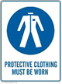 | 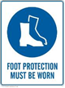 |  | 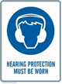 |  |  | 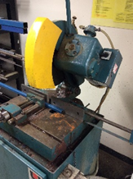

PRE-OPERATIONAL SAFETY
- Check workspaces and walkways to ensure that no slip/trip-hazards are present.
- Check that all safety guards are in position and are set to the minimum clearance from the workpiece being cut.
- Locate and ensure you are familiar with the operation of the ON/OFF starter and E-Stop (if fitted).
- Ensure all locks are securely tightened.
- Ensure table and work area is clear of all tools, off-cut metal.
- Faulty equipment must not be used. Immediately report suspect equipment.

OPERATIONAL SAFETY PRECAUTIONS
- Do not cut freehand, clamp material firmly in vice.
- Allow the saw blade to obtain maximum speed before making a cut.
- Make sure cooling fluid is flowing over saw blade.
- Always stand to one side of the line of cut.
- Never remove off cuts from the saw table while the saw is running.
- Before making adjustments switch off and bring the machine to a complete standstill.
- Never leave offcuts on saw table while cutting.
- Do not clamp material shorter that the width of clamping vice.
- Ensure long material is supported on the right side of machine.

HOUSEKEEPING
- Switch off the machine.
- Leave the machine in a safe, clean and tidy state.
Date of last review: |  |  | Signature:

