STANDARD OPERATING PROCEDURE
Hedge Trimmer - Electric |  |  |  |  |  | SOP Number: |  | RA Number:
 |  |  |  |  |  | 027SOP |  | 053RA
DO NOT use / operate / this equipment or complete the task unless you have been trained.
Motorised cutting blades, keep hands clear at all times.
POTENTIAL RISKS: Lacerations; Hazardous Chemicals; Hazardous Manual Tasks; Gravity; Noise; Flying Objects
 |  | 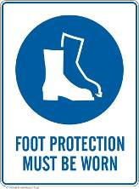 | 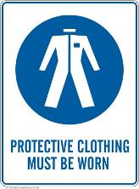 |  |  |  | 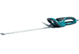

PRE-OPERATIONAL SAFETY
- Check for obvious faults and defects including electric cord for signs of wear or damage.
- Equipment has current test and tag
- Identify ON/OFF switch.
- Wear appropriate PPE.

OPERATIONAL SAFETY PRECAUTIONS
- Transport the machine with the scabbard on and the blade facing away from you.
- Hold trimmer firmly with both hands.
- Ensure firm footing.
- If excessive dust is present use an appropriate respirator.
- Move your body with the trimmer; do not twist from the waist.
- Keep cord free from cutting blades at all times
- Do not cut over shoulder height.
- Do not walk with trimmer whilst blades are moving
- Do not use in the rain or wet conditions.
- Ensure bystanders are at least 5 metres away from your working position.
- If using the machine for prolonged periods take breaks to avoid tiredness and fatigue.

HOUSEKEEPING
- Ensure cutters have stopped before removing waste material
- Ensure cutters have stopped before placing trimmer on the ground.
- Clean the cutting blade with a resin solvent.
- Ensure equipment is returned to storage area after use.
Date of last review: |  |  |  | Signature:

