STANDARD OPERATING PROCEDURE
Hot Water Urn |  |  |  |  |  | SOP Number: |  | RA Number:
 |  |  |  |  |  | 018SOP |  | 105RA
DO NOT use / operate / this equipment or complete the task unless you have been trained.
POTENTIAL RISKS: Electricity, Hazardous Manual Tasks, Extreme Temperatures
 |  |  |  |  |  |  | 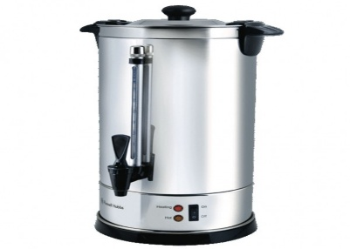

PRE-OPERATIONAL SAFETY
- Check that the cord and plug has no visual damage (e.g. nicks in the cord).
- Check that test and tag label is attached and in date.

OPERATIONAL SAFETY PRECAUTIONS
- Place urn on a level surface with sufficient strength to carry weight of full urn and within reach of a power outlet. DO NOT PLACE ON FOLDING TABLES.
- Ensure there is enough room above the urn to allow for filling.
- Position the urn tap where it can be easily reached whilst in use.
- Never place the urn on or near a hot burner or a heated oven.
- Do not allow the cord to touch hot surfaces or hang over a table or counter.
- Fill the urn with water to the desired level and replace the urn lid.
- Take the water to the urn, do not lift or carry an urn when filled with water, (or use a trolley).
- Plug the urn into a power outlet and switch the power on.
- Beware of scalding steam when lifting urn lid.
- When not in use, turn the control knob and power outlet switch off.

HOUSEKEEPING
- If the urn is not being used the next day it is recommended that it is emptied, cleaned and dried.
- Switch the power off and remove the plug from the wall power outlet.
- Allow the urn to cool down fully.
- Empty the contents of the urn before attempting to lift or move it.
- Never immerse the urn, cord or plug in water or any other liquid.
- Wipe over the outside of the urn with a damp cloth.
- A mild dishwashing detergent may be used if required.
- To clean the inside of the urn use a non-metallic scourer and soapy water, rinsing well with clean water.
- Ensure the power cord and switches remain dry.
- Build-up of scale or crusty deposits can be removed by following the manufacturer’s instructions or use of a descaling product.
- After long periods of non-use rinse the urn with clean water prior to operation.
Date of last review: |  |  |  | Signature:

