STANDARD OPERATING PROCEDURE
Ladders |  |  |  |  |  | SOP Number: | RA Number:
 |  |  |  |  |  | 026SOP | 055RA
DO NOT use / operate / this equipment or complete the task unless you have been trained.
POTENTIAL RISKS: Hazardous Manual Tasks, Gravity, Mechanical, Radiation
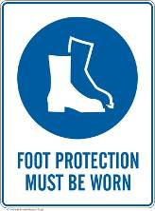 |  |  |  |  | 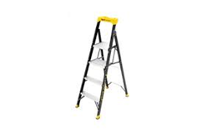 | 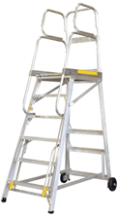  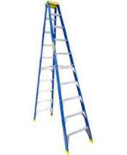  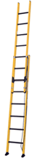

PRE-OPERATIONAL SAFETY
- Always refer to the manufacturer’s label for load ratings and other safety information. The rated capacity must be sufficient to accommodate the weight of the person and everything that they are carrying.
- ALWAYS inspect the ladder before each use to ensure there are no worn parts or damage before climbing.
- If any component is found to be worn or damaged immediately remove the ladder from service, tag it as “Out-of- Service” and notify the appropriate Supervisor / Manager. FIX ANY FAULTS BEFORE USE.

OPERATIONAL SAFETY PRECAUTIONS
- Choose the right ladder for the job and ensure correct PPE is worn dependant on the location where ladder is being used.
- Ensure the ladder is the proper height. The top step and next two rungs down on a ladder are not intended for climbing. 3 rungs must extend above the roof if using an extension ladder. DO NOT improvise to gain additional height.
- Inspect the area where ladder is to be used to ensure there are no surface, aerial or other hazards.
- When transporting your ladder check for overhead power lines, live wires, service cabling, electrical fittings (e.g. ceiling fans) or electrical hazards. Use two people to carry and erect long or heavy ladders.
- Ensure the ladder is placed on dry, firm, level surface and not subject to skidding or slipping. Position the ladder until all feet have firm contact with the floor. Always check there is no rocking movement before climbing the ladder. DO NOT use blocks, rocks, boxes, or other items to “level up” or gain height. Use an approved ladder leveller, if required.
- For step type ladders ensure that the spreaders are secured / locked in position. For extension type ladders ensure a 1:4 ratio is used when setting up and the base is secured either by another person or other means at all times when a person is on the ladder.
- If castors are fitted to the ladder, ensure rubber feet have firm contact with the floor when the springs are depressed.
- DO NOT position a ladder in an area where it can be bumped or dislodged (e.g. doorway, passage way, window opening). If a ladder needs to be located where it can be struck or displaced, secure the area by locking doors, placing barricades or use another appropriate action. DO NOT use a ladder in strong winds, heavy weather or when visibility is poor (e.g. poorly lit areas).
- Ensure the ladder is fully opened before climbing. Always face towards the ladder when climbing, and always maintain three points of contact with the ladder. Tool bags or tool belts can help to keep hands free.
- Only one person is permitted on the ladder at any time. A second person may stand alongside the ladder and help to steady it, or pass materials/tools up if required. DO NOT lift heavy weights that unbalance the ladder or yourself.
- Maintain a safe, balanced stance while on the ladder. DO NOT over reach whilst using the ladder. Always get off to shift position – never walk” the ladder whilst on it. Always maintain the majority of your body weight inside the perimeter of the work platform or ladder stiles and ensure that 3 points of contact are always in place i.e. two feet and one hand.
Date of last review: |  |  |  | Signature:

