STANDARD OPERATING PROCEDURE
Laser Cutter |  |  |  |  |  | SOP Number: |  | RA Number:
 |  |  |  |  |  | 021SOP |  | 057RA
DO NOT use / operate / this equipment or complete the task unless you have been trained.
POTENTIAL RISKS: Fire, Electricity, Hazardous Chemicals, Radiation, Extreme Temperatures and Mechanical
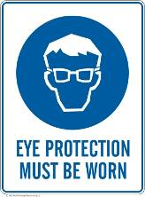 |  |  |  |  |  |  | 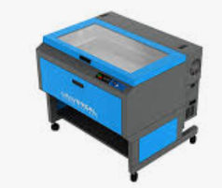

PRE-OPERATIONAL SAFETY
- Check all software and machine settings carefully before commencing any cutting operation.
- Check operating lenses are clean.
- Check nozzle has no build-up of material on it.
- Load and position the material on the table.
- Ensure the access door is closed before starting the laser cutter.
- Ensure air assist has commenced automatically when machine is switched on.
- Some materials may produce toxic fumes. Check Safety Data Sheet (SDS) prior to use.
- Ensure power cords are positioned to avoid creating a trip hazard.
- Faulty equipment must not be used. Immediately report suspect machinery to Tech Studies Coordinator.

OPERATIONAL SAFETY PRECAUTIONS
- DO NOT place any reflective metals into the laser cabinet as the beam may be reflected out and cause injury.
- DO NOT LEAVE THE MACHINE UNATTENDED WHEN IN USE
- A CO2 fire extinguisher is available adjacent the machine.
- Check that fumes / smoke is being extracted through the filter system when machine is operating.
- Only permissible material is to be cut. If unsure if a material is suitable for laser cutting – DO NOT PROCEED, refer to operating manual.
- DO NOT operate the machine if any safety features have been modified, disabled or removed.
- DO NOT open the lid until the fan and light have ceased operating.
- DO NOT store tools or parts on the machine.

HOUSEKEEPING
- Remove all off cuts and waste, sweep/vacuum the area. Leave the machine and work area in a safe, clean & tidy state.
- Return surplus material to stock and dispose of waste material in the appropriate recycling or waste bins.
Date of last review: |  |  |  | Signature:

