STANDARD OPERATING PROCEDURE
Sliding Table Saw |  |  |  |  |  | SOP Number: |  | RA Number:
 |  |  |  |  |  | 074SOP |  | 077RA
DO NOT use / operate / this equipment or complete the task unless you have been trained.
POTENTIAL RISKS: Cutting hands / Pinch & squash injuries / Flying chips and debris / Eye injuries / Excessive noise
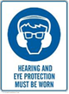 | 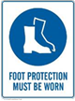 |  | 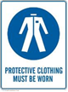 |  |  |  | 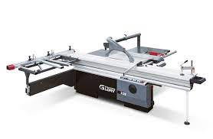

PRE-OPERATIONAL SAFETY
- Clear the area around the machine.
- Locate and check the operation of the emergency stop.
- Check the blade condition and type is correct for the task.
- Check riving knife is correctly set and securely mounted.
- Do not store tools and parts on top of the machine.
- The fence must be set for all use of the machine.
- The guard should be set as low as possible. Where auto adjusting, the saw blade guard should return to the table without assistance.
- Faulty equipment must not be used. Immediately report suspect machinery.

OPERATIONAL SAFETY PRECAUTIONS
- Stand to one side when turning on power and feeding material past blade.
- Never leave the machine while it is still running.
- Check material being machined for nails and loose knots etc.
- Do not force materials past saw blade.
- Wait for the machine to stop and isolate before making any adjustments.
- Do not place your hands in line with the cut.
- Use a push stick for material less that 150mm wide and to remove offcuts.
- Do not attempt to remove off-cuts or saw dust from the table with your hands when the blade is in motion.

HOUSEKEEPING
- Switch off and lock out the machine.
- Leave the machine in a safe, clean and tidy state.
- Remove false fence if one was used.

Date of last review: |  |  |  | Signature:

