STANDARD OPERATING PROCEDURE
Timber Planer |  |  |  |  |  | SOP Number: |  | RA Number:
 |  |  |  |  |  | 080SOP |  | 081RA
DO NOT use / operate / this equipment or complete the task unless you have been trained.
POTENTIAL RISKS: Cutting hands, Pinch and squash injuries, Flying chips and debris , Eye injuries, Excessive noise, Respiratory issues
 |  |  |  |  |  |  | 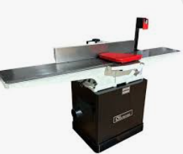

PRE-OPERATIONAL SAFETY
- Check guards are in position and operational.
- Locate and check the operation of the emergency stop.
- Minimum length of material 300mm
- Set depth of cut (maximum 3 millimetres) and lock table.
- Check and lock fence in position.
- One piece of material to be machined at a time.
- Faulty equipment must not be used. Immediately report suspect machinery.
- Do not attempt to plane end grain.

OPERATIONAL SAFETY PRECAUTIONS
- Never allow hands to pass over the cutter.
- Never leave the machine while it is still running.
- Wait for the machine to stop and isolate before making any adjustments.

HOUSEKEEPING
- Switch off the machine.
- Leave the machine in a safe, clean and tidy state.
- Reset the depth of the cut to 1mm or 0mm after use.
- Reset cutter block guards.
- Lockout machine.
- Sweep the machine down and remove all chips, shaving and wood dust.

FORBIDDEN
- Planing end grain.
- Planing timber 300mm or less in length
Date of last review: |  |  |  | Signature:

