STANDARD OPERATING PROCEDURE
Vacuum Cleaner |  |  |  |  |  | SOP Number: |  | RA Number:
 |  |  |  |  |  | 082SOP |  | 083RA
DO NOT use / operate / this equipment or complete the task unless you have been trained.
POTENTIAL RISKS: Exposure to hazards associated with electricity, ergonomics, slip, trips and inhalation of dust.
 | 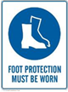 | 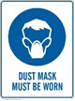 |  |  |  |  | 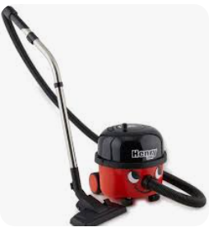

PRE-OPERATIONAL SAFETY
- Unwind and inspect electrical cord completely. Ensure it has current test tag.
- Use only attachments supplied or approved by the manufacturer .

OPERATIONAL SAFETY PRECAUTIONS
- Exercise caution in relation to electrical lead.
- Stand upright ensuring all operations with this equipment are undertaken with the intention of maintaining the back’s natural curves.
- Ensure equipment is used in accordance with manufacturer’s instructions.
- Operate during times of low pedestrian traffic.
- Do not attempt to suck up water and avoid working in wet areas.
- Never attempt to pick up flammable materials or combustible liquids.
- Switch off the machine, switch off at the power point and disconnect lead from power source when moving from one area to another.

HOUSEKEEPING
- Switch off vacuum cleaner and disconnect the lead from the power after each use.
- Hoses and electrical leads should be coiled and tied for protection against damage and for ease of storing.
- Dispose of disposable dust bag when full.
- Wear appropriate dust mask when cleaning dust bags to prevent inhalation of fine dust.
- Ensure equipment is returned to storage area after use.

Date of last review: |  |  |  | Signature:

