Workstation Setup Guidelines
Setting up your workstation
The following checklist is a step-by-step approach for use by workers located at a workstation. Work through the checklist on your own or with another person and observe each other’s postures and body positions.
When setting up the position of furniture and equipment it is important to try new positions to find the most comfortable arrangement. Give yourself a chance to get used to any changes, as it make take several hours or even days to determine the best position. It may even take a few tries to get the best arrangement and if it doesn’t work, you can always reset it.
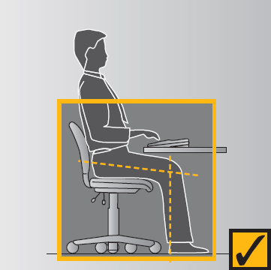  Figure 1 | Chair  When adjusting your chair refer to any instructions that may be provided with the chair or have someone show you.  Seat  Height – adjust chair height so feet are comfortable flat on the floor, thighs are approx. horizontal and the lower legs are approx. vertical. Low heeled shoes will improve comfort of the legs with the chair at this height. See Figure 1.  Tilt (if available) – set to horizontal or slightly forward to suit your comfort.  Back support  Height – start by raising the backrest to its maximum height. Then sit in the chair and check the fit of the backrest to the curve of the lower back. If it’s not comfortable, lower the height by several centimetres and try this position. See Figure 2.  Repeat this adjustment and try each new position until the most comfortable fit is found. Ensure that the backrest supports the curve of your lower back and is not placed too low.  Forward / backward position – adjust the position of the backrest until a comfortable pressure is exerted on the lower back area while seated in the usual working posture at the desk. See Figure 2.  Armrests  Armrests are usually not recommended unless they are short, fit under the desk or are adjustable. If your chair has armrests ensure they do not prevent from getting as close to the desk as you need (see Figure 3) or that they impinge on your elbows while you are working. If this is the case, either remove them, or replace them with a smaller or adjustable option. See Figure 4.
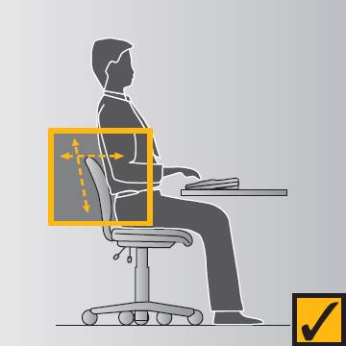
Figure 2
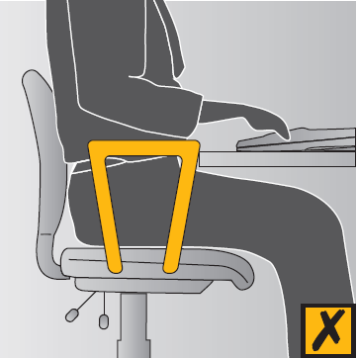
Figure 3
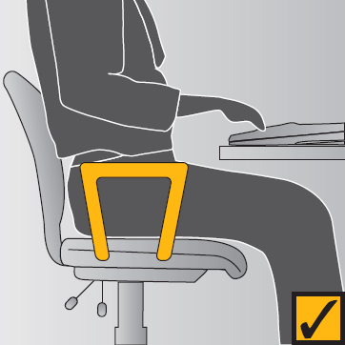
Figure 4
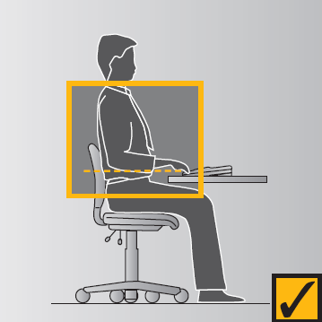  Figure 5 | Desk  If you have a height-adjustable desk  After having adjusted your chair, adjust the desk so the top surface is just below elbow height. See Figure 5.  To determine your elbow height, relax your shoulders and bend your elbows to about 90 degrees and check the elbow height against the desk height. See Figure 6.
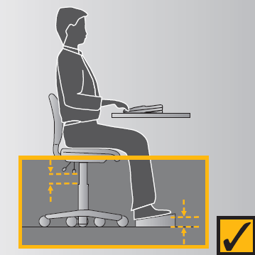  Figure 6 | If you don’t have a height-adjustable desk  If the chair has been adjusted and the desk is higher or lower than the elbow, other forms of adjustment will be required. Start by measuring the height difference between the desk and your elbow.  If the desk is too high – raise the chair by the measured difference and use a footrest. See Figure 7. Otherwise, you may be able to lower the desk by the cutting the legs. See Figure 6.  If the desk is too low – raise the height of the desk by extending the leg length or sitting it on wooden blocks or something similar.  Keyboard  Angle – tilt the keyboard using the feet at the back to suit your level of comfort. The common and preferred setting is where the feet are lowered so the keyboard sits flat on the desk. This assists in preventing awkward postures of the wrists.  Position on the desk – place the keyboard as close to the front of the edge as is comfortable (see Figure 7).
Figure 7
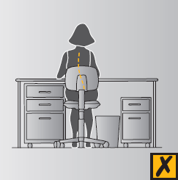  Figure 8 | Clearance under the desk  General items, like computer hard drives, boxes of documents or files, rubbish bins and mobile drawers should not be stored under desks where they will decrease or interfere with the space required for the legs. This may force you to adopt a twisted or awkward posture of the spine (and create trip hazards). See Figures 8 and 9.  Drawers  Most commonly used items should be placed in the top desk drawer to improve access and reduce searching and bending movements. Where drawers are fitted to the desk, equipment such as the keyboard and computer screen should be arranged on the desk so that you can sit comfortably in the leg-well space.  General storage on desk  In/out trays – place trays at the outer reach sector (see Figure 10). In-trays should not be located above shoulder level.  Stationery – a variety of containers are available for mixed stationery items. These should also be stored at the outer reach sector (see Figure 10) or in the top desk drawer.  Reference books and folders – large or heavy references such as telephone directories and manuals should either be stored within close reach or in a nearby position where you need to stand to access them. Handling of these items should not be conducted at the limit of your reach capacity while sitting, as this can result in undue strain on the back, shoulder and arm muscles.
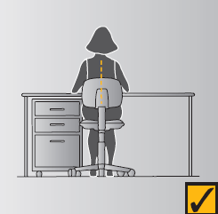
Figure 9
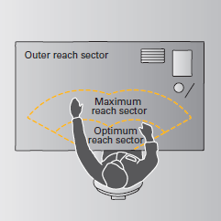
Figure 10
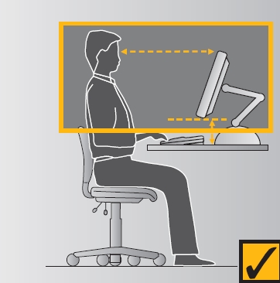  Figure 11 | Mouse  Place the mouse mat directly beside the end of the keyboard on your preferred side. Use the mouse in this position and always aim to keep the mouse on the mat during use.  If you frequently use the mouse in your work you may wish to:  - learn to use it with both hands so that you can swap between the right and left sides for improved comfort;  - set the tracking speed of the mouse to a setting that suits you;  - maintain your mouse to keep it in good working order (e.g., keeping it clean on the inside); and  - where possible, try and avoid holding on to the mouse when not in use.  Document Holder  The position of the document holder depends on your need to view and reach the documents and the type of document holder that is used. For continuous or frequent data entry where the source document is observed more than, or the same amount as the screen:  - Place the screen slightly to one side so that the document holder is directly in front of the user (see Figure 12); OR  - Place the document holder in a similar position to the screen where it is slightly to one side and you look evenly between the two (see Figure 13).  An A-frame style book rest that sits on top of the desk is the most practical and can be set at different angles (see Figure 14). It is usually best placed so that it supports documents on an inclined angle between the keyboard and the screen (see Figure 12).  A level or swivel arm document holder suspends the document above the desk at eye level. Anchor it to the desk on either the left or right of the screen, according to your preference, and place it directly beside the screen  Telephone  The telephone should be placed wither within or at the limit of the optimum reach sector, depending on the amount of use (see Figure 10). The placement should enable the user to operate the telephone without the need to move their trunk to grasp the handset or to operate the numeric and function buttons.  Computer Screen  The screen should be positioned once the chair and desk heights have been established.  Height – the screen should be positioned so that the top of the screen is level with, or slightly lower than, your eyes when you are sitting upright (see Figure 11). If the screen does not have a raising device such as a monitor stand, you may be able to use telephone books to raise the screen height on a temporary basis.  Distance from the eye – first place the screen so that it is approx. an arm’s length away from your usual seated position (see Figure 11). Trail a position and if necessary move if further away or closer as required.  Positioning the screen – the screen should be placed so that it does not face windows, catching reflections from the windows, or have a window directly behind it causing glare from the window (see Figure 15 and 16).
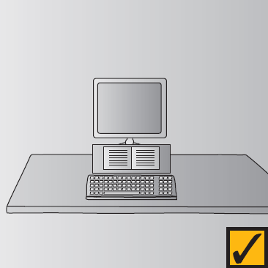
Figure 12
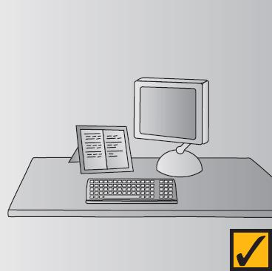
Figure 13
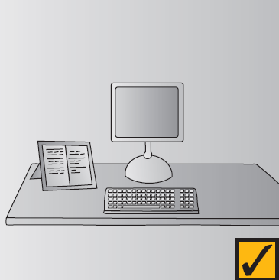
Figure 14
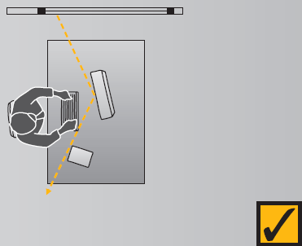
Figure 15
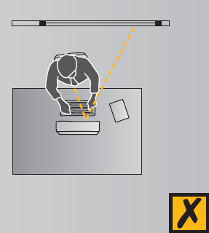
Figure 16
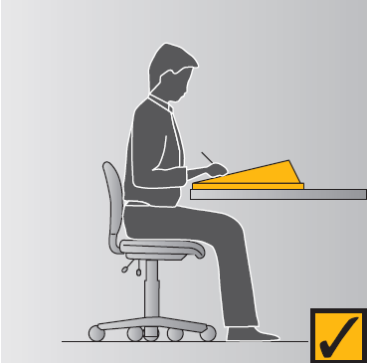  Figure 17 | Angled reading & writing surface  An angled board can improve neck comfort where a job involves a lot of reading and handwriting. It should be placed immediately in front of the user on top of the desk (see Figure 17).

